**Project 2 Proposal:**

Topic: Sleep in the USA

Data set: <https://chronicdata.cdc.gov/500-Cities/500-Cities-Sleeping-less-than-7-hours-among-adults/eqbn-8mpz>

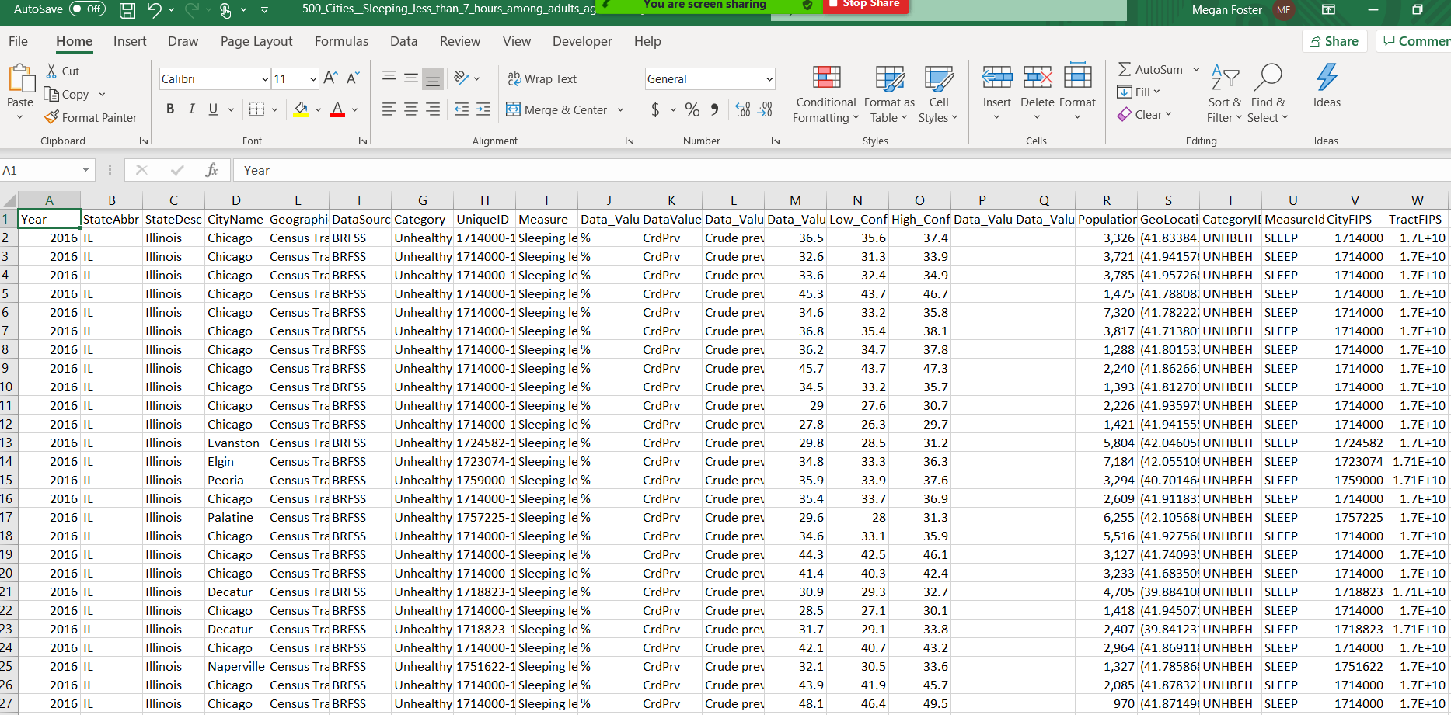

**Visualization Vision**: Map of USA at the Top of Page where you can click a state to update visualizations on the dashboard

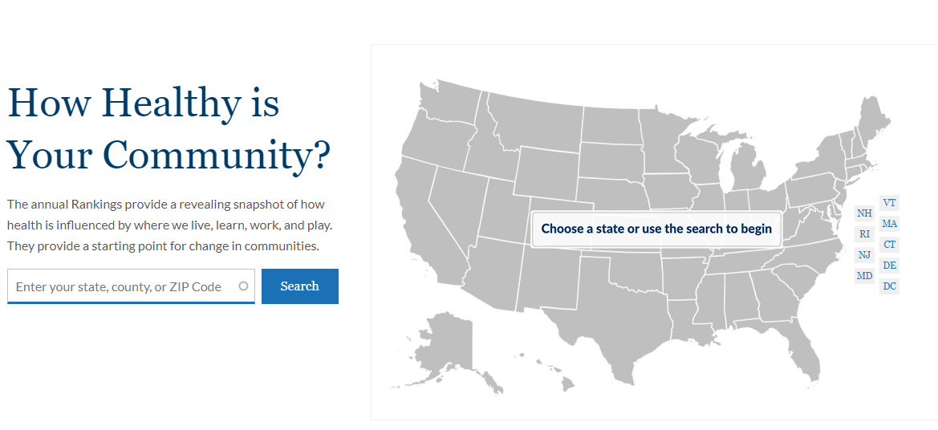

Visualizations will compare sleep habits/prevalence against factors:

* Income
* Age
* Location
* Disease/Chronic Conditions
* Family Composition

Visualization Ideas:

